Book Bowls & Appointments on the Go with the Acuity Client App
Members can easily book and manage their appointments from their phone using the Acuity Scheduling Client App. There’s no need to visit the website each time.
👍 Why Use the App?
* Book quickly from your phone
* See upcoming bowls sessions and appointments
* No need to remember the website link each time
* Easy to manage or check bookings on the go
✅ Step 1: Download the App
Download the Acuity Scheduling Client App from:
Apple App Store (iPhone)
Google Play Store (Android)
You’re looking for this
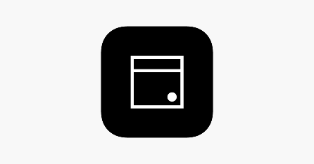
✅ Step 2: Add Our Bowling Club to the App
Once the app is installed:
1. Open the app
2. Tap the + sign on the home screen
3. In Business scheduling URL field, enter our booking link
4. Tap Add Business
💡 Tip: Save the club once and it will stay in your app for future bookings.
If you’ve booked with us before and already created a client account, the club may appear automatically when you log in.
✅ Step 3: Book an Appointment
1. From the app home screen, tap Mooloolaba Bowls Club
2. The booking page opens
3. Select your appointment (bowls, coaching, event, etc.)
4. Choose a time and complete your booking — just like booking online
✅ Step 4: Log In (Recommended)
Logging in lets you track all your bookings, whether you made them on your phone or computer.
To log in:
1. Tap the account icon (bottom-right)
2. Tap Log In
3. Enter your email and password

New members:
1. Tap the account icon
2. Tap Create Account
3. Enter your email and set a password
✔️ Creating an account ensures all your bookings appear in one place.

📅 Viewing Your Appointments
Logged in members will see:
All appointments booked via the app and the website
Not logged in?
You’ll only see bookings made through the app
⚠️ Important:
If you book online without logging in, those bookings won’t appear in the app later.

